Previous Model :----
MobileNet V2 (Stats) :--
Train Accuracy Vs Validation Accuracy Graph
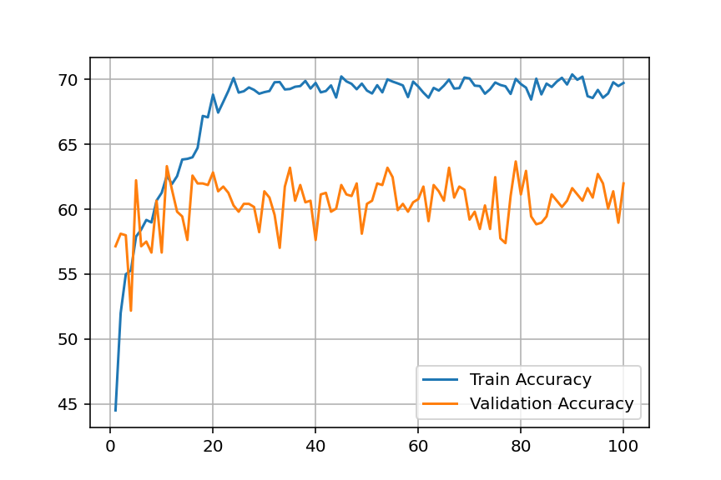
ROC-AUC Curve
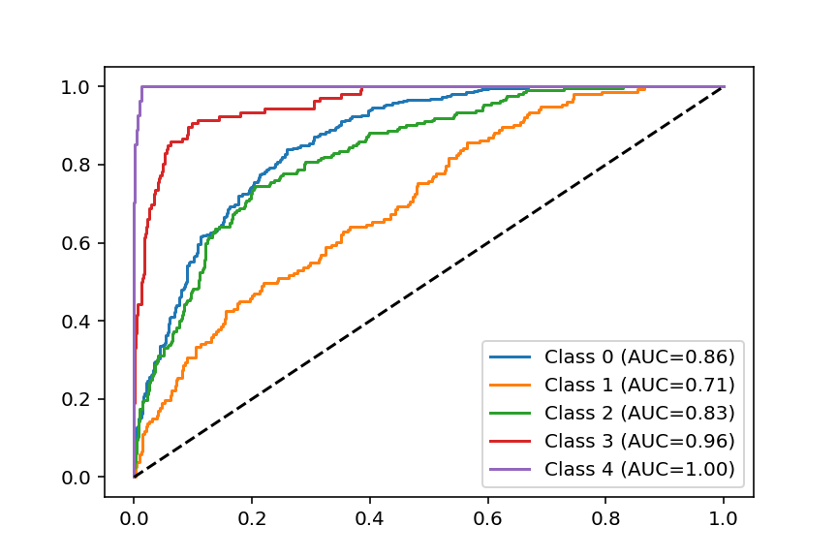
2ND MODEL: ---
INCEPTION RESNET V2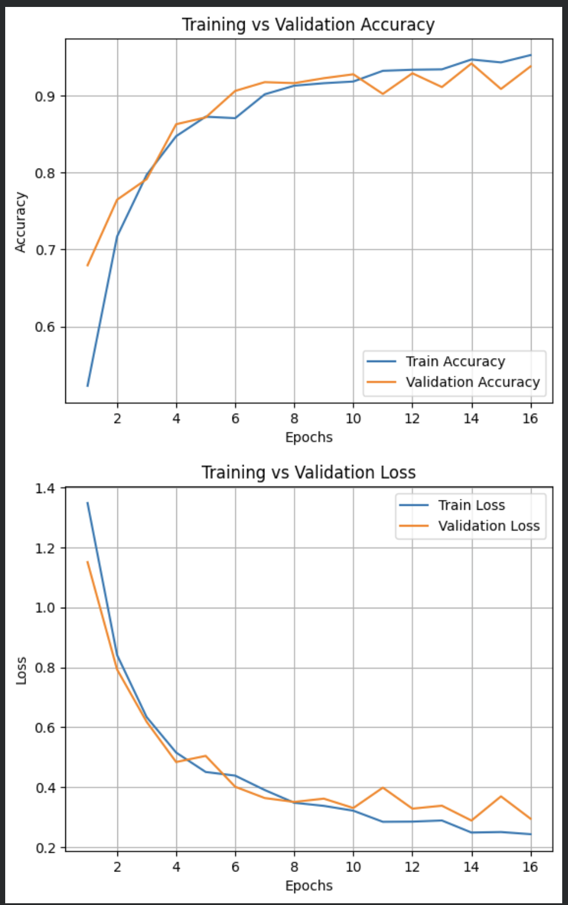
TRAIN ACC VS VALIDATION ACC AND TRAIN LOSS VS VALIDATION LOSS GRAPH

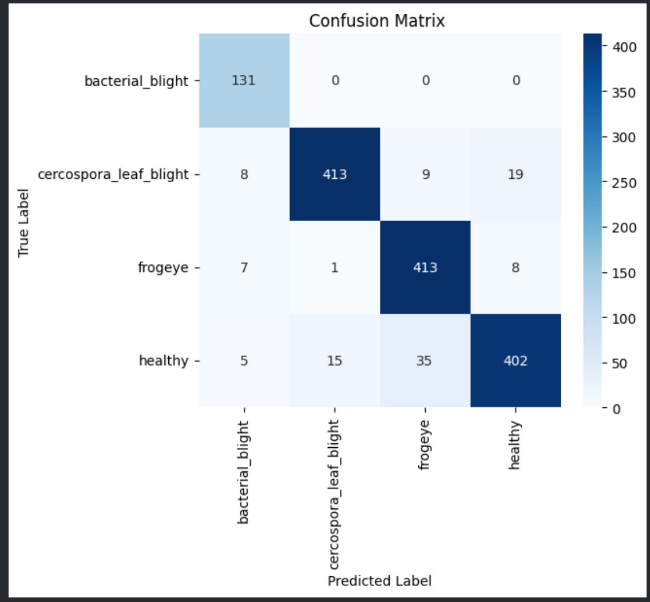
CONFUSION MATRIX

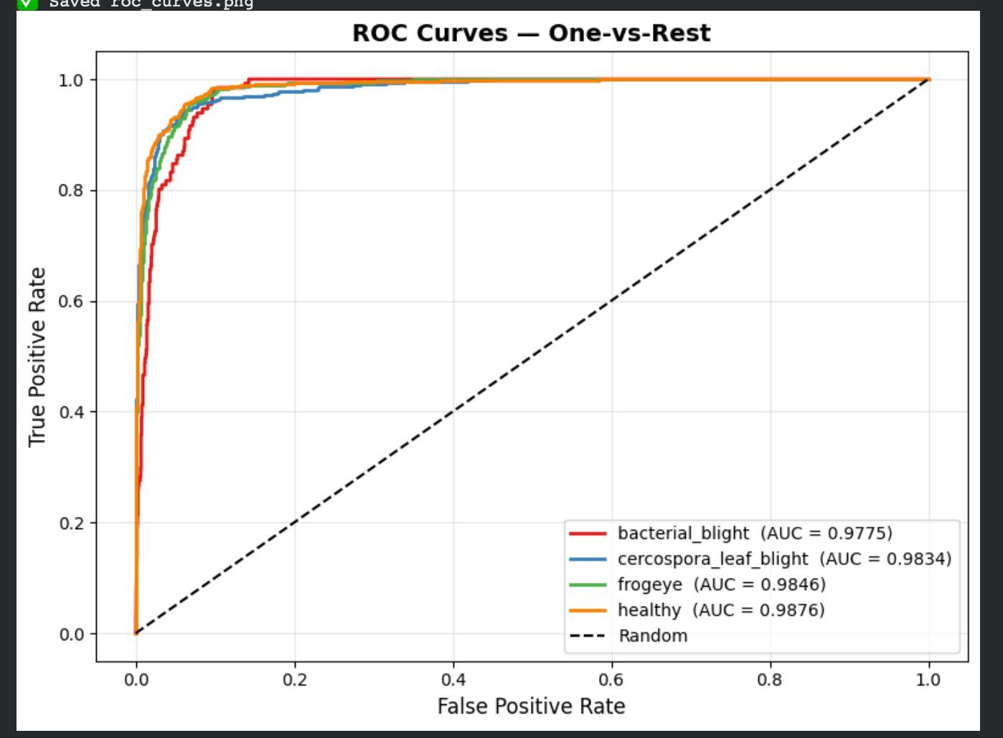
ROC CURVE

